THE PROCLAIMERS
MELROSE RUGBY CLUB - BATTERY DYKES FIELD
SATURDAY 15 JUNE

THE BIGGEST MUSIC EVENT EVER TO BE STAGED IN THE BORDERS

4500 people will flock to the Borders this June to see The Proclaimers headline over 5 hours of world class live music. Overlooked by Ferny and Eildon Hills on the banks of the River Tweed, the concert beside the historic Melrose Abbey is the first ever to be staged in the area in a state of the art Kayam tent.

THE DAY’S RUNNING ORDER
3.00pm Gates open
4.30pm MAGPIE BLUE
5.20pm ZOE GRAHAM
6.15pm BE CHARLOTTE
7.15pm FATHERSON
8.30pm THE PROCLAIMERS
10.00pm Finish

Within our wonderful Food and Drinks Village you will find licensed bars and some of the finest Scottish street food available including Fire & Dough Pizza, Stooge-Burger, Mac Shack, Rost, Babu Bombay Kitchen and Mucky Face Churos and Coffee available to enjoy at picnic tables throughout the day.

SITE & TOWN MAPS AND ALL TRAVEL, PARKING AND SITE INFO FOR TICKET HOLDERS –

There is event parking not too long a walk from the festival site in Melrose at the Glebe Pitch on Waverley Road. Parking your car here for the day costs £5 cash on arrival and there is a limited shuttle bus service to the site for those that may need (£2 each way). See attached concert road map.

Thanks to Scotrail, there will be additional carriages on the trains going to the Borders from Edinburgh (and all stops in between) throughout the day and leaving Tweedbank Station after the show. Again, a limited shuttle bus service is available for those that need (£3 each way).

For those travelling from Edinburgh, we recommend that you leave the car behind - if you can - and come by bus. Happy Bus is running return buses from Waterloo Place in the centre of Edinburgh directly to the concert site.
https://www.happybus.co.uk/the-proclaimers-melrose-15th-june-2019-c-898

If you are in Melrose for longer than just the concert itself, you should check out The Borders Book Festival. The event takes place at Harmony Garden and Orchard, Melrose during Thursday 13 – Sunday 16 June where festival-goers can enjoy an amazing range of events. Full details can be viewed and downloaded here: http://bit.ly/BBF19W

A final limited number of tickets have just been released today and are available from www.ticketmaster.co.uk/the-proclaimers-melrose-06-15-2019/event/36005574DBC09B0F

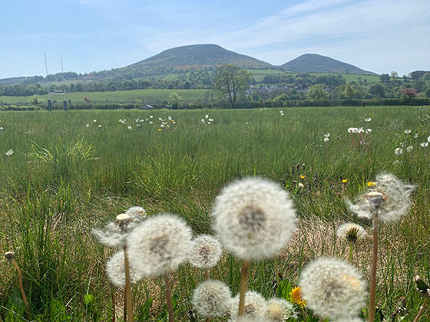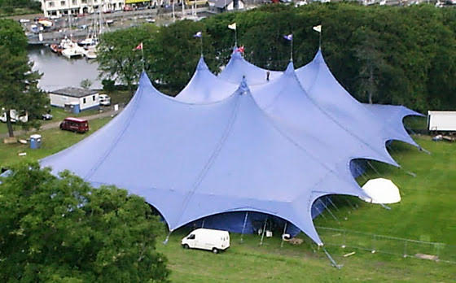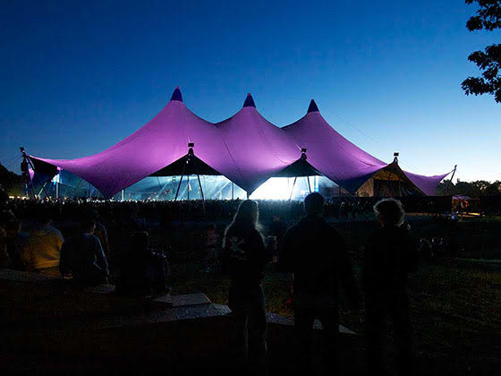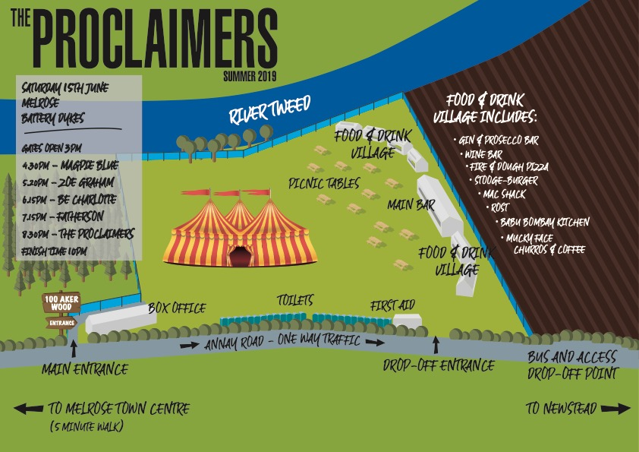

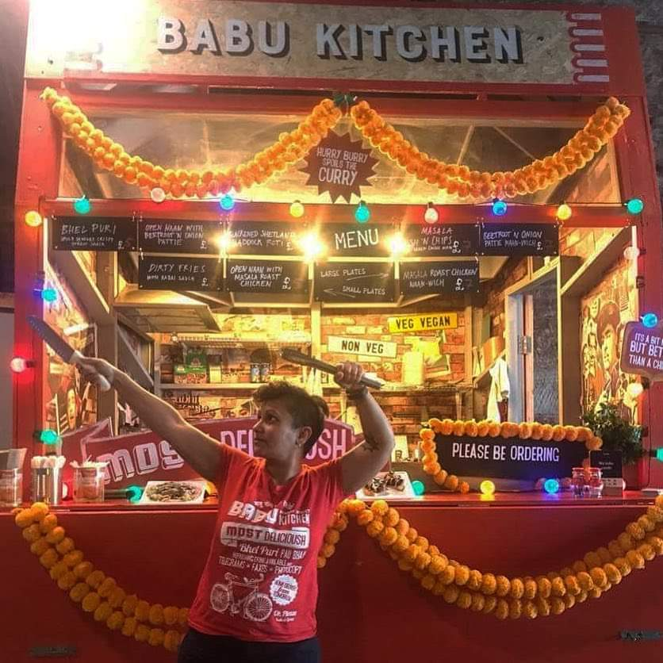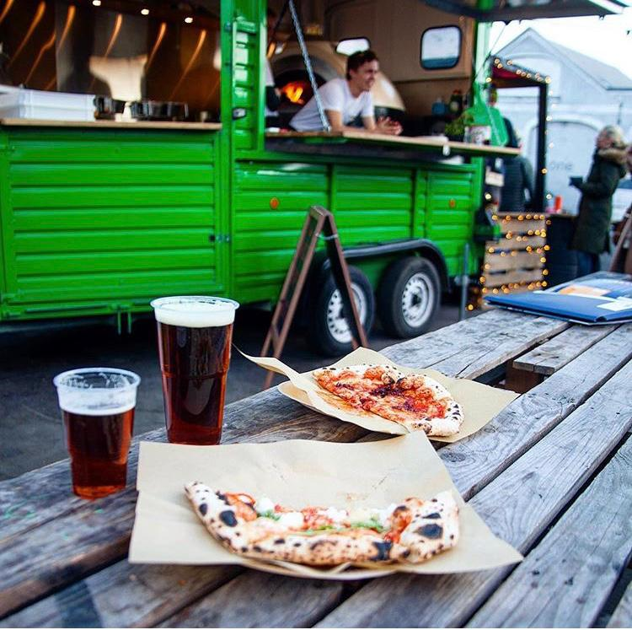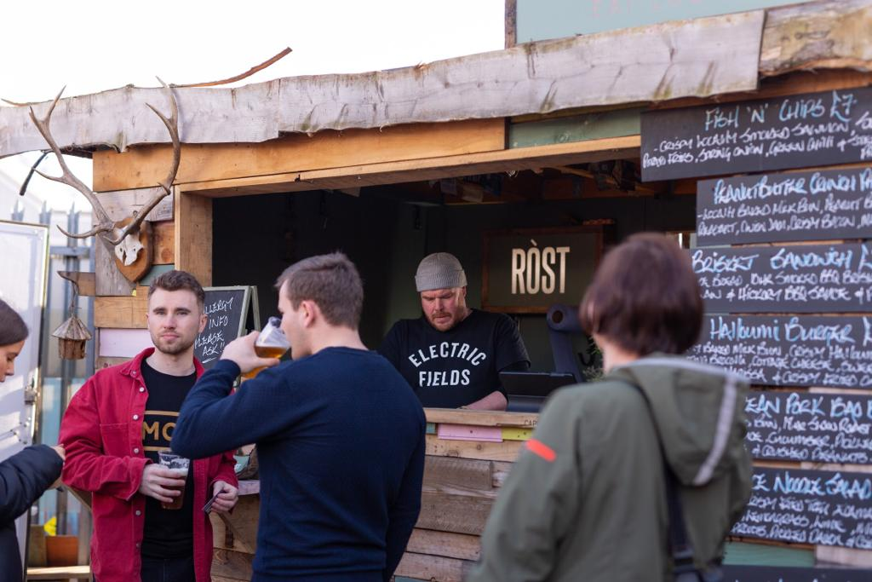

FATHERSON
The upwards trajectory of Fatherson's blossoming career serves a heartening reminder that the hype machine is no substitute for talent, authenticity and graft. This is a band afforded no shortcuts to get where they are today, a success story built on word-of-mouth conversions. And they wouldn't have it any other way. Attend any Fatherson gig and you'll find a room echo with lyrics being sung back en masse by adoring fans.

The articulate, brooding, emotive rock of the Glasgow-based band can be found on all three of their studio albums, I Am An Island, Open Book and Sum Of All Your Parts.

Their popularity scaled greater heights with the release of Open Book on Easy Life Records, a subdivision of Sony Music, in the summer of 2016. When it went straight in at No.2 in the official Scottish album charts, Fatherson found themselves sandwiched between Paul Simon and Coldplay.

Other highlights to date include supporting Kings Of Leon in Vienna, selling out a headline show at the legendary Glasgow Barrowland and packing out a 12,000-capacity tent at T in the Park. They have also played in the UK and Europe with Biffy Clyro, Kings of Leon, Twin Atlantic, Enter Shikari, Frightened Rabbit, Idlewild and Augustines.

FATHERSON ‘MAKING WAVES’ - https://youtu.be/ai2qa5qQk78
www.fathersonband.com

BE CHARLOTTE
Some pop stars make music for the sake of it. But for 21-year-old Be Charlotte – music is about meaning.

it's the combination of her remarkable songwriting talent, a knack for sweeping melodies and the fierce sense of identity and self-worth which makes heads turn, not only in the UK. Even although she is still at the beginning of her career Be Charlotte has toured around Europe, North America and Asia as well as as sharing the stage with Major Lazer in Africa in 2018.

Woven into every note of her glimmering pop songs, anthemic beats and immediate vocals which radiate that quiet yet determined personality, there's this extraordinary effort to inspire others. In the lyrics, the listener will find honesty, a level of maturity beyond her years, and reflection. She has taken influence from classic songwriters such as Bob Dylan and Tracy Chapman and instinctively applied them to her love of modern pop and hip-hop.

Since starting to find her voice as a teenager with an acoustic guitar in Dundee, Scotland, Be Charlotte has been focussed on finding inner strength and inspiring others to do the same and is ready to speak up.

"I hope that my lyrics can encourage listeners to discover strength within themselves, rather than looking for validation from others."
She’s not a perfect princess figure and never wanted to be. She's content in being herself and singing in her own voice and is ready to take on the world.

BE CHARLOTTE ‘DO NOT DISTURB’ - https://m.youtube.com/watch?v=qymXzSp6Vh8

www.iambecharlotte.com

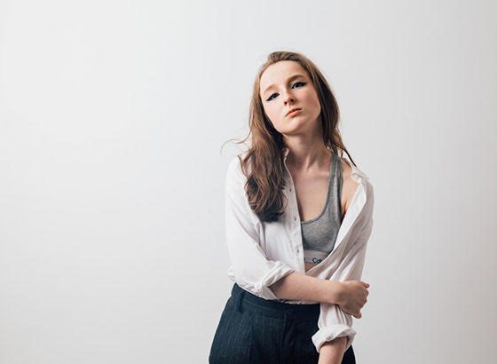

ZOE GRAHAM
There is an impressive maturity and attention to detail in Zoe Graham’s music that sets this accomplished young songwriter apart from her peers. On stage, you will find her either with band or fleshing out the instrumentation with loop pedals on solo outings. But when Zoe pares it back to just a vocal and acoustic guitar, as she does on the achingly poignant The Anniesland Lights (from her recent Hacket & Knackered EP), that is when you know you're in the company of someone very special indeed. Championed by Radio Scotland's Roddy Hart and with multiple Celtic Connections appearances to her name, Zoe Graham's understated charms will not stay below the radar for much longer.

ZOE GRAHAM ‘THE ANNIESLAND LIGHTS’ - https://www.youtube.com/watch?v=hvbf-nRdWs8&feature=youtu.be

www.zoegrahammusic.com

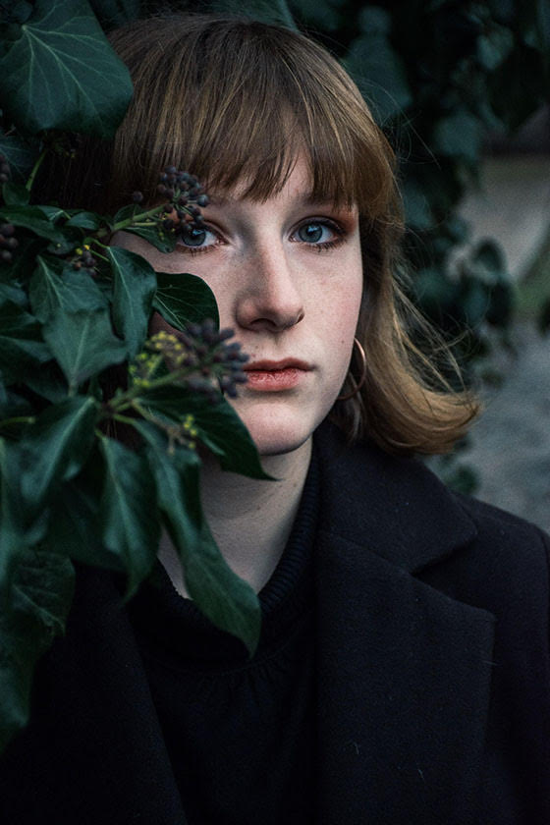

MAGPIE BLUE

Magpie Blue is the guise of Millie Hanlon Cole, who at just 19 radiates an emotional
intelligence and bad-ass attitude of someone who's already learnt how to dodge a bullet. Magpie Blue, originally from the Scottish Borders, has spent her teens honing her live show and is already a proficient live performer having supported artists such as Sam Evian and Sam Brookes. Originally singing just using her high falsetto or head voice, Millie discovered her range and tenor voice at 14.
Nowadays, her songs have been said to encapsulate the sound of Jeff Buckley, while also being reminiscent of Anna Calvi and PJ Harvey.

MAGPIE BLUE ‘HIT THE ROAD’ - https://youtu.be/dGMMy_w-MwQ

https://www.instagram.com/magpieblueofficial/

