THE PROCLAIMERS ANNOUNCE NEW ALBUM

DENTURES OUT

FEATURING MANIC STREET PREACHERS’ JAMES DEAN BRADFIELD ON GUITAR

RELEASED 16 SEPTEMBER

LISTEN TO THE ALBUM’S FIRST SINGLE, ‘THE WORLD THAT WAS’:
https://proclaimers.lnk.to/twtwPR/youtube

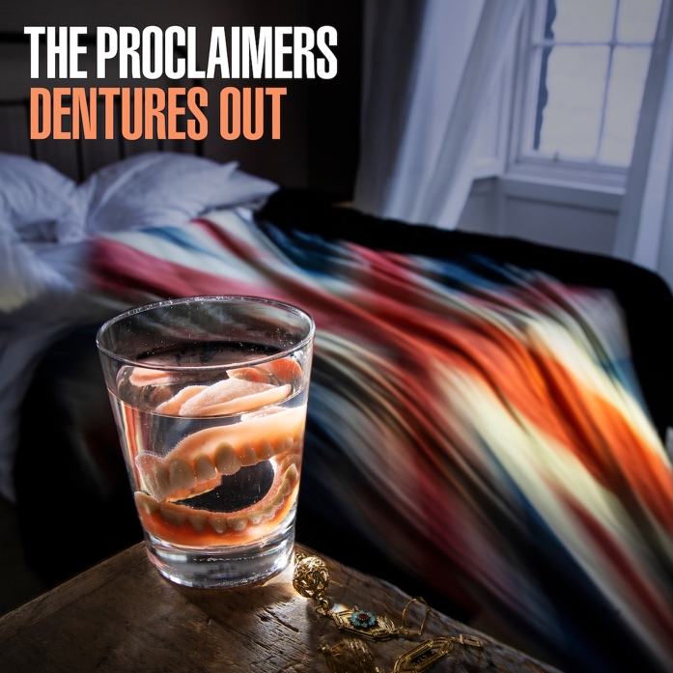

EXTENSIVE SUMMER AND AUTUMN TOUR

HI-RES ALBUM SLEEVE AND NEW PHOTO: https://spaces.hightail.com/space/jTP6PD6X3X

Today Cooking Vinyl release ‘The World That Was’, the first track from The Proclaimers’ new album Dentures Out. It is brothers Craig and Charlie Reid’s first album since 2018’s hugely acclaimed Angry Cyclist.
Thirty-five years since the release of their landmark debut album This Is The Story, and 34 since the release of Sunshine On Leith, the second album that made them international stars, The Proclaimers are back with their 12th studio album. And, at the ripe young age of 60, the fire and ire of Craig and Charlie Reid remain righteously undimmed. Dentures Out is a record of the times, for the times, the twins at their political, observational, satirical and fist-punchingly tuneful best.
Dentures Out is 13 songs clocking in at a lean, tight, focused 34 minutes. Only one number, the closing ‘What The Audience Knew’, busts the 180-second mark. The rest are sub-three-minute miniatures of polemical pop perfection, recorded at Rockfield in Wales in three quick weeks in spring 2022, lent six-string wings by guest guitarist James Dean Bradfield (who plays on the title track and ‘Things As They Are’, the latter an epic song, the James Bond theme that never was) and produced by Dave Eringa, his third consecutive album with the Scotsmen.
On their most political album since Sunshine On Leith, in the lyrical firing line are: the weaponising of nostalgia for electoral capital, porcine press barons, the comforting but distracting illusion of destiny, the hysterical bubble of modern life, the misery of a Sunday stripped of fun by Calvinist puritanism, and the romancing of a recent past that lands us with a cosily commodified heritage culture.
The first single, ‘The World That Was’, is a rocking singalong that finds the Reids in full-throated vigour, on a song about the frustration of how nostalgia was pressed into service during the pandemic with illusions to wartime warmth. This theme is further explored on the title track. ‘Dentures Out’ is an anti-nostalgia song, with Britain as a dilapidated, toothless old crone, a diminished country, clinging onto former, vanished glories.
‘Feast Your Eyes’s strings-laden sweep and big production amplify a song reflecting on the yawning emptiness and loneliness felt during the first lockdown – a time when even a twin-brother duo who’ve been making music for four decades was too big a bubble. That period early in the pandemic also birthed ‘Sundays By John Calvin’, a swinging but maudlin ballad that reflects a long-held hatred for the week’s dreariest day. The Reids grew up in a Scotland where every kid knew the image of swings and playparks in the Western Isles being shackled by religious leaders on Sundays. During Covid, the rest of the UK saw that, too.
Then there’s the rollicking ‘Drop Dead Destiny’, a piano-and-guitar-solo belter that showcases the time-served skills of The Proclaimers’ live band. A song which questions the notion of destiny, pointing out life is really a multiple series of events.
This is The Proclaimers of 2022: fast, funny, furious. Firmly looking forwards and pushing brilliantly onwards. The past is a foreign country, and not a place Craig and Charlie Reid ever want to visit. All these years in, they’re still about the next song, the next gig, the next opportunity. They sound like they always did. Only better.
Dentures Out is released on 16 September and will be available on the following formats:
CD
LP: back vinyl / white label (D2C only)
Cassette
Digital download

Buy link: https://proclaimers.lnk.to/denturesoutPR

Track list:
- Dentures Out
- The World That Was
- Feast Your Eyes
- Praise
- News To Nietzsche
- Things As They Are
- Signs Of Love
- Drop Dead Destiny
- The Recent Past
- Sundays By John Calvin
- Draw Another Line
- Play The Man
- What The Audience Knew

The Proclaimers recently kicked off their 14-month World tour with a main stage appearance at the Isle of Wight Festival. They will be playing a series of summer festivals and regional concerts, followed by a 35-date UK and Ireland tour from October to November.

THE PROCLAIMERS LIVE 2022

June
F 10 Stoke Victoria Halls
S 18 Isle Of Wight Festival
S 25 Warrington Parr Hall
S 26 Llandudno NWT

July
S 02 Chillfest Tring
F 08 Bournemouth Pavilion
S 09 Truro Hall for Cornwall
S 16 Sudbury Smile For Arran Trust
S 17 Folk by the Oak
F 22 St Helens Rugby Stadium Paul Heaton & Jacqui Abbott
S 23 Doncaster Keepmoat Stadium
S 30 Camp Bestival Dorset Lulworth Castle

August
F 05 Scarborough Spa Royal Hall
S06 Skegness Embassy Theatre
F 19 Camp Bestival Weston Park Shropshire
S 21 Hardwick Festival
T 25 Amsterdam Melkweg
F 26 Ostende W-Festival

September
S 03 Jersey Weekender

October
S 08 Newcastle O2 City Hall
S 09 Stockton The Globe
M 10 Liverpool Philharmonic Hall
W 12 Carlisle Sands Centre
T 13 Bradford St Georges Hall
S 15 Blackburn King Georges Hall
S 16 Salford The Lowry
M 17 Birmingham Symphony Hall
W 19 York Barbican
T 20 Sheffield City Hall
S 22 Oxford New Theatre
S 23 Southend Cliffs Pavilion
T 25 Nottingham Royal Concert Hall
W 26 London Palladium
F 27 Ipswich Regent
S 29 Plymouth Pavilions
S 30 Southampton Mayflower

November
T 01 Bath Forum
W 02 Cardiff St Davids Hall
F 04 Leicester De Monfort Hall
S 05 Cambridge Corn Exchange
M 07 Brighton Dome
F 18 Belfast Waterfront
S 19 Dublin NCH
T 24 Motherwell Concert Hall
F 25 Dunfermline Alhambra
S 26 Dundee Caird Hall

December
T 01 Glasgow O2 Academy
F 02 Glasgow O2 Academy
S 03 Kilmarnock Grand Hall
F 09 Edinburgh Playhouse
S 10 Edinburgh Playhouse
W 14 Perth Concert Hall
T 15 Inverness Leisure Centre
S 17 Aberdeen P&J Live

NOTES FOR EDITORS
Strikingly individual, twin brothers Craig and Charlie Reid emerged 34 years ago with their debut album This Is The Story and Top 3 single ‘Letter from America’. Since then their enduring appeal across generations has have over the years seen them enjoy huge success across the globe.

The Proclaimers songs are timeless, capturing a gamut of human emotions, written with poignancy, emotional honesty, political fire and wit. Their songs feature at weddings, funerals and everything in-between and there is one song, an early celebration of falling head over heels in love that is known the world over and has become a staggering global anthem. There are many others that have gained great popularity in different parts of the planet and then there is a wide cross section of sublime songs embraced by a multitude that has kept up with The Proclaimers studio albums, compilation collections and extensive touring over three decades.

The Proclaimers have carved out a niche for themselves in the netherworld where pop, folk, new wave and punk collide. In the process, they have enjoyed Gold and Platinum singles and albums in the UK, USA, Canada, Australia and New Zealand. They have even inspired a musical, the play and film Sunshine on Leith. The movie was the fifth highest grossing Independent UK film of 2013. The musical had its fourth UK run from April to June in 2018 with its biggest production to date by West Yorkshire Playhouse.

On BBC Radio 4’s Desert Island discs, actor David Tennant describes his first track by The Proclaimers - "I could have chosen any and every track from this band, probably my favourite band of all time. They write the most spectacular songs, big hearted, uncynical passionate songs."

Their 2018 album Angry Cyclist was released to immense acclaim, becoming their 8th UK Top 40 album debuting in the UK Official Album charts at 17 and at number 3 in the UK Official Independent Album Charts.

The Proclaimers “Angry Cyclist World Tour” began in July 2018 and ended in September 2019, 111 shows in 14 countries to over 400,0000 people. The tour began in Stroud, England and ended at The Hydro in Glasgow. The tour included their biggest ever tours of Scotland, England, Canada, New Zealand and Australia and notably in June 2019, The Proclaimers opened The Pyramid Stage for their 7th appearance at Glastonbury. The Proclaimers July 2019 Edinburgh Castle concert sold out in just under 10 minutes with Castle Concerts reporting this as the fastest sell out in their 25-year history. A second show at Edinburgh Castle was added, this show also sold out within 24 hours, which Castle Concerts reporting as never-before-seen demand.

